Training and Assessment Strategy (TAS)

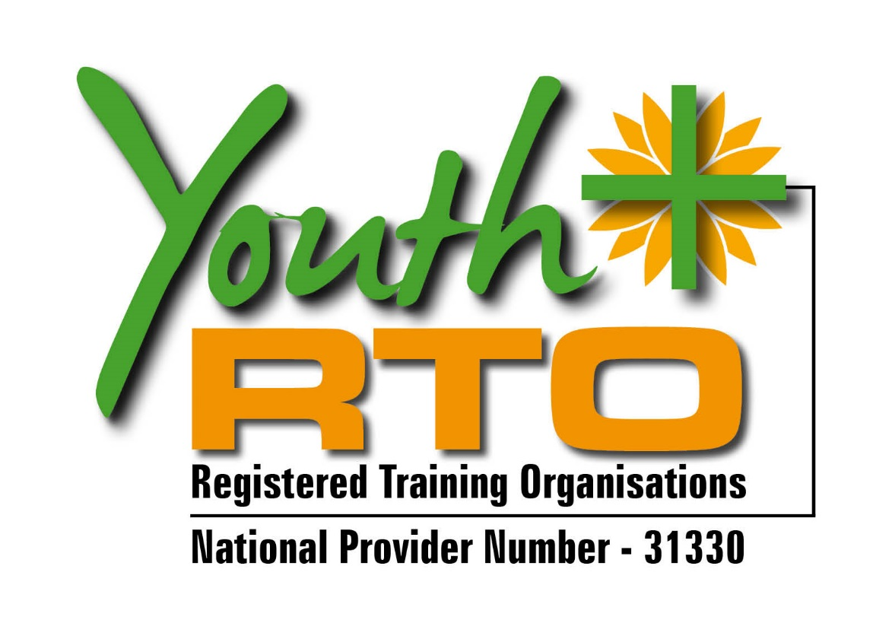
RTO Name: | Edmund Rice Education Australia T/A Youth Plus
RTO Code: | 31330
Qualification: | 30999QLD Certificate I in Functional Literacy
Learner Group: | Young people engaged in an educational re-engagement program including pathways to work (YCLC)
Date Implemented: | 1st February 2016
The Training and Assessment Strategies and practice are the approach of, and method adopted by, an RTO with respect to training and assessment designed to enable learners to meet the requirements of the training package or accredited course.
Glossary, Users’ Guide to the Standards for Registered Training Organisations (RTOs) 2015, ASQA, 2014
Contents
1. Qualification Overview 4
1.1 Identifying Information 4
1.2 Qualification Packaging Rules 4
1.3 Units of Competency 5
1.4 Learners & Clients 6
2. Course Delivery 6
2.1 Environment & Location 6
2.2 Duration & Amount of Training 7
2.3 Mode of Delivery 7
2.4 Pathways 8
2.5 Entry Requirements 8
2.6 Employability Skills Summary / Foundation Skills 8
2.7 Recognition Processes 9
2.8 Educational & Support Services 9
2.9 Physical Resources 9
2.10 Learning Resources 10
3 Course Structure & Delivery Plan 11
4. Assessment 13
4.1 Evidence Gathering Techniques 13
5. Human Resources 16
6. Assessment Moderation 19
6.1 Moderation Meetings 19
6.2 Validation 19
6.3 Assessment Feedback 19
6.4 Transition Arrangements 19
7. Review of Training and Assessment Strategy (TAS) 20

1. Qualification Overview

1.1 Identifying Information
This section states the information identifying the RTO and the training products, as well as the person authorising the use of the strategy document.
RTO Name | Edmund Rice Education Australia T/A Youth Plus
RTO Code | 31330
Training Package Code | Accredited Course
Training Package Title | N/A
Version (Release) of Training Package | 1.1- 16th May 2013 | Status | Current | ☒
 |  |  | Superseded | ☐
Qualification Code | 30999QLD
Qualification Title | Certificate I in Functional Literacy
Delivery Period | February 2016
Contact Person | Sandra Lee – RTO Operations Manager
Contact Details | training@youthplus.edu.au  www.youthplus.edu.au  PO Box 498 Red Hill 4059, 07 3447 1009
Authorised By | Sandra Lee

1.2 Qualification Packaging Rules
Based on information available from www.training.gov.au the following packaging rules apply for completion of this qualification: http://training.gov.au/Training/Details/BSB10115
Total Number of Units | 6
Number of Core Units | 6
Number of Elective Units | 0
Other notes (imported units, levels of units, etc) | Click here to enter text.

1.3 Units of Competency
Consistent with the qualification packaging rules, the units listed below will be delivered for this qualification. The code and title of each unit is provided as well as an indication of core, elective (Elec), pre-requisite (Pre)/co-requisite (Co) and licensing requirements (Lic).
Code | Title | Core | Elec | Pre | Co | Lic
BSBCMM101A | Apply basic communication skills | ☒ | ☐ | ☐ | ☐ | ☐
LITRDG101A | Interpret and read basic text documents | ☒ | ☐ | ☐ | ☐ | ☐
LITWRT101A | Writing to communicate | ☒ | ☐ | ☐ | ☐ | ☐
LITLRN101A | Setting personal goals and learning pathways | ☒ | ☐ | ☐ | ☐ | ☐
LITCOM101A | Apply speaking and listening skills for effective communication | ☒ | ☐ | ☐ | ☐ | ☐
LITADM101A | Use organizational skills to achieve personal goals | ☒ | ☐ | ☐ | ☐ | ☐

Description of licensing requirements (if indicated above) | There are no licensing requirements for this Certification

1.4 Learners & Clients
The key clients for this qualification are secondary school students enrolled in the Youth and Community Learning Centre (YCLC). This particular cohort of young people includes those who are considered at risk and who may not have developed a level of literacy or numeracy that would enable them to function successfully in society, seek further education and training or employment. The course will assist these young people to build some foundation skills that will enable them to build pathways to work or to further study options.

2. Course Delivery

2.1 Environment & Location
The environment where the qualification will be delivered includes:
☒ Institutional delivery
☒ Simulated work/industry environment
☒ Experiential learning activities
☐ Other (specify) Click here to enter text.
The simulated work environment will be achieved by (provide examples/descriptions):
YCLC has the relevant equipment and environment to simulate the necessary learning experiences that will allow the young people to achieve the competencies

The location of training facilities for this target group will be (list all addresses and type of facility e.g., library, computer room, commercial kitchen, etc):
Classrooms
Simulated work environment
Outdoor program environments

2.2 Duration & Amount of Training
The Volume of Learning for a Certificate I is 600-1200 hours. As a component of this, the amount of training provided in this instance of course delivery is 600 hours, comprising of:
- 240 hours of supervised instruction per year
- 300 hours of unsupervised activities blended with other subject or school activities.
- 60 hours of online activities
*Include a justification for any differences between volume of learning requirements and this instance of course delivery

2.3 Mode of Delivery
Delivery will mainly be:
☒ Face to face
☒ Online
☐ Correspondence
☐ On-the-job (indicate number of days/hours)
☒ Combination
☐ Other (describe)

2.4 Pathways

Study Pathways
The further study pathways available to learners who undertake this qualification include:
10306NAT Certificate II in Functional Literacy or other Certificate II courses

Note: This RTO may not offer all qualifications listed above in possible pathways

Employment Pathways
The following employment pathways are available to students who complete this qualification:
nil

2.5 Entry Requirements
The specific course entry requirements are (for example, LLN, technology skills or pre-requisite qualifications):
YCLC tests each young person with a variety of testing to ensure that they have the literacy/numeracy levels required for enrolment in the course.
Personal Learning plans are formulated with all young people and VET qualifications may form part of their learning pathways.

2.6 Employability Skills Summary / Foundation Skills
The following Foundation Skills will be developed through this course
Oral Communication
Reading
Writing
Numeracy
Navigate the world of work
Interact with others
Get the work done

2.7 Recognition Processes
Learners are able to have their competency from prior learning and work experience recognised in this qualification through the following arrangements:
Transcripts of previously achieved competencies can be submitted to trainer for transference to the RTO and credit transfer results recorded in the VETTRAK system.
RPL is to be assessed via a process of competency conversations, 3rd party reporting and submission of portfolio of evidence.

2.8 Educational & Support Services
In accordance with the Standards for RTOs 2015, at a minimum, support should include:
- Identifying particular requirements (such as literacy, numeracy, English language or physical capabilities) learners would need to complete each course, and
- Developing strategies to make support available where gaps are identified.
This may include providing:
- Language, Literacy & Numeracy (LLN) support
- Assistive technology
- Additional tutorials, and/or
- Other mechanisms, such as assistance in using technology for online delivery components
The following support will be available to learners:
Language, Literacy and Numeracy support.
One-on-one tutorial support.

The following processes will be applied for students considered to be ”at risk”:
One-on-one support to ensure understanding of requirements of course.
Instructions to be read verbally where needed.
Regular monitoring of progress- adjusting support as necessary.

2.9 Physical Resources
All staff involved in the delivery and assessment of this qualification have:
☒ Direct access to the current version of the units of competency, assessment requirements, relevant Training Package and companion volumes
☒ Access to appropriate support materials relevant to their areas of delivery and assessment
☒ Access to the latest copy of assessment tools used for this program
☒ Access to training and assessment resources to meet the requirements of learners with special needs including procedures for making reasonable adjustments to the assessment process
☒ Access to equipment and facilities to meet the requirements of each unit of competency and successfully implement the program (further information provided below).
Specifically, the following physical resources are available for the delivery and assessment of the units of competency selected for this qualification. Where there is more than one training location, specify the location for the specific resources. (If there is not sufficient space, indicate where to find a comprehensive listing of resources).
- Classrooms
- Simulated work places
- Computers with internet access.
The following physical resources owned by external organisations are available for use during delivery and assessment, and a Third Party Agreement outlining the details of this arrangement is kept by YCLC and by Youthplus RTO.
- Classrooms
- Simulated work place
- Computers with internet access
- Resources for delivery of the content

2.10 Learning Resources
The following learning resources will be available to ensure learners are able to obtain and absorb the required skills and knowledge required prior to assessment:
- Workbooks
- Computers with internet access
- Classrooms
- Variety of reading materials

3 Course Structure & Delivery Plan
The units of competency will be delivered as:
☐ Stand-alone units
☐ Clusters of units
☒ Combination of stand-alone and clustered
The table below provides a description of the theme or topic and sequencing of units throughout the program. It also outlines the delivery schedule, the learning materials required, the mode (face-to-face, online, workplace, etc) and the hours required. An indication is given if assessment will occur (refer to assessment section for more information)
Week | Topic/Theme | Unit/s of Competency (Code) | Delivery Mode | Hours | Resources Required  (Learning, Physical etc) | Assessment
1-10 | Setting goals and developing organizational skills | LITLRN101A  LITADM101A | In class, unsupervised and simulated environments | 80 hours supervised and 120 hours online and blended with other subjects | Trainer for supervised hours  Personal learning plan  Organisational tools  Simulated environments | ☒
11-20  and ongoing | Reading and writing | LITRDG101A  LITWRT101A | In class, unsupervised and simulated environments | 80 hours supervised and 120 hours online, unsupervised and blended with other subjects | Trainer for supervised hours  Variety of reading materials  Models of writing genres | ☒
21-30 | Communication | LITCOM101A  BSBCMM101A | In class, unsupervised, online learning and practice, and simulated environments | 80 hours supervised, and 120 hours online, practice and blended with other subjects. | Trainer for supervised hours  Computers and internet access  Simulated real-life environments | ☒

4. Assessment

4.1 Evidence Gathering Techniques
The following table provides a general overview of the evidence gathering techniques that will be used to assess each unit of competency. Assessors have flexibility in selecting which techniques or tools they will use to gather sufficient evidence, in a range of contexts, to meet the requirements of the training package and made a decision regarding competence.
Technique Legend
Examples of techniques may include observation of performance, questioning, workbooks, practical tasks, simulation, interviews, third party reports, etc. The techniques used for this qualification and target group are as follows:
A | Observation of performance
B | Verbal questioning
C | Workbooks
D | Third party report
E | Assessment task

Assessment Matrix
Unit Code | Unit Title | Technique (refer to legend)
 |  | A | B | C | D | E | F | Notes regarding timing and specific resources required
BSBCMM101A | Apply basic communication skills | ☒ | ☐ | ☒ | ☐ | ☐ | ☐ | This topic will be revisited across all subsequent units.
LITRDG101A | Interpret and read basic text documents | ☒ | ☒ | ☐ | ☐ | ☐ | ☐ | This topic will be embedded in all subsequent units
LITWRT101A | Writing to communicate | ☒ | ☐ | ☒ | ☐ | ☒ | ☐ | Access to computer/keyboard
LITLRN101A | Setting personal goals and learning pathways | ☒ | ☐ | ☐ | ☒ | ☐ | ☐ | Click here to enter text.
LITCOM101A | Apply speaking and listening skills for effective communication | ☒ | ☒ | ☐ | ☐ | ☐ | ☐
LITADM101A | Use organizational skills to achieve personal goals | ☒ | ☐ | ☒ | ☐ | ☒ | ☐ | Click here to enter text.

Please note any adjustments that may be required to cater for different learner requirements:
- Instructions may be read to the learner if reading is not a required skill of the unit.
- Additional tutorial support.
- One-on-one support to complete tasks.
- Access to technology.

5. Human Resources
In order to comply with the requirements of clauses 1.1-1.16 of the Standards for RTOs 2015, the RTO ensures all trainers and assessors comply with these requirements and copies of qualifications are stored together with the PD evidence with the trainer/assessor profile.
Documentation is kept for each trainer/assessor to demonstrate their competence and currency in line with the relevant directive described above. These documents are held on file at YCLC and are provided to the Youthplus RTO.

Staff Matrix
Qualification being delivered/ assessed | Staff Member/s |  | Trainer | Assessor | Train/Assess Qualification  (code) |  | T&A Currency | Qualification on file | Vocational Qualification  (code/name) |  | Vocational Currency | Qualifications on file
10306NAT | Mary Smith |  | ☒ | ☒ | TAE40110 |  | ☒ | ☒ | Diploma of Adult language and literacy |  | ☒ | ☒
30999QLD Certificate I in Functional Literacy | Dave Trenaman |  | ☒ | ☒ | TAE40110 |  | ☒ | ☒ | Bachelor of Education (Science) |  | ☒ | ☒
 | Bill Smith |  | ☒ | ☒ | TAE40110 |  | ☒ | ☒ | Dip Teaching and Diploma in Applied Linguistics (Literacy) |  | ☒ | ☒
 | Joshua Waters |  | ☒ | ☒ | TAE40110 |  | ☒ | ☒ | CHC42112 Cert IV in Career Development |  | ☒ | ☒
 | Julian Booth |  | ☒ | ☒ | TAE40110 |  | ☒ | ☒ | Bachelor of Arts (Music) |  | ☒ | ☒
* Add rows as required

6. Assessment Moderation

6.1 Moderation Meetings
Moderation meetings will be held according to a set schedule to ensure a systematic approach. This is separate to the validation process and is intended to ensure reliable judgements have been made prior to issuing results to learners.
Moderation of judgements will occur on a regular basis, prior to issuing results to students, at least every semester The moderation process involves the review of samples folios of evidence (assessments and RPL submissions) to confirm reliability and consistency of judgements that meet the requirements of the training package as well as meet industry standards. Materials such as learning and reference materials, training package assessment guidelines, feedback forms and other resources will be utilised.
Discussions and recommendations during moderation meetings will be recorded on a Moderation Minutes Form, stored at YCLC and forwarded to Youthplus RTO.

6.2 Validation
Validation will occur as requested by Youthplus RTO.

6.3 Assessment Feedback
Feedback and input from students and other stakeholders will be sought, analysed and acted upon, where necessary, on a regular basis. Information gained will form part of any review of materials and in the validation and moderation processes. Feedback will be sought through the following process:
Given the nature of the student cohort, feedback will be gathered through verbal conversations. With a focus on staff/student relationships, this mode is likely to be the best indicator of accurate feedback.

6.4 Transition Arrangements
The RTO Manager is subscribed to the following email updates to ensure the RTO is advised of any changes to the Training Package:
☒ Australian Skills Quality Authority  ☒ Training.gov.au  ☒ VET Reform Taskforce | ☒ Velg Training Newsletters  ☐ Other – specify Click here to enter text.  ☒ ISC Newsletters – indicate which ISCs Click here to enter text.
When there is a change to the Training Package that impacts on this TAS, the RTO Manager will notify all staff affected as soon as possible.
The RTO complies with clauses 1.26 & 1.27 of the Standards for RTOs 2015. When there are major changes to the Training Package, the RTO Manager and management team will review the changes made and create a plan to transition to the new training package requirements and cater for completion arrangements for students where possible. The progress of the transition will be monitored by the RTO Manager and the management team.
Transition arrangements must be completed within 12 months of changes being published on training.gov.au for superseded qualifications and two years for deleted training products (except Skill Sets and units of competency which are 12 months).

7. Industry Engagement
Date of Review | Business Name | Contact Person | Contact Details
Click here to enter text. | Click here to enter text. | Click here to enter text. | Phone: Click here to enter text.  Email: Click here to enter text.
Click here to enter text. | Click here to enter text. | Click here to enter text. | Phone: Click here to enter text.  Email: Click here to enter text.

8. Review of Training and Assessment Strategy (TAS)
This TAS will be reviewed as required by changes to the Training Package, organisational resources and in meeting individual client needs. A systematic approach will also be used to review the TAS and any recommended changes will be discussed by trainers, assessors, the RTO Manager and Management Team. These changes will be implemented when/if approved.
Approved by:
RTO Manager Name: | Sandra Lee
RTO Manager Signature:
Date:

Document adapted from: © Velg Training, Version 2, March 2015

