Student behaviour support plan
Purpose
Catholic schools in the Diocese of Toowoomba provide all students with opportunities to develop positive behaviours and self-discipline within a supportive and vibrant Christ-centred community.

Good Samaritan College is committed to providing a caring and safe environment, recognising the individuality and dignity of each student and member of the community. We provide students with experiences of hope and promise, give practical expression to the Gospel message, and foster life-giving relationships.

The Student Engagement and Wellbeing Standards are designed to facilitate high standards of behaviour, promoting inclusive practices, so that the learning and teaching in our school can be effective and students can participate positively within our school community.

Shared values and expectations
At Good Samaritan College
- Gospel values are lived, and all members of the school community are valued and treated with dignity and respect
- all members of the school community feel safe, supported and respected
- students are encouraged and supported to take greater responsibility for their own learning and participation as members of the whole school community, developing as individual learners who increasingly manage their own learning and growth by setting goals and managing resources to achieve these goals
- pastorally caring practices that include non-coercive and non-discriminatory behaviour are defined, modelled and reinforced by all members of the school community, and
- formal sanctions including detention, suspension, negotiated change of school and exclusion are considered only when all other approaches have been exhausted, or rejected.

Our College community has identified the following school rules to teach and promote our high standards of responsible behaviour.
- Be safe
- Be respectful
- Be responsible
- Be resilient

Rights and responsibilities
Every member of our College community has a right to fully participate in an educational environment that is safe, supportive, and inclusive. Everyone deserves to be treated with respect and dignity.

College (principals, teachers and school staff)
- Staff at Good Samaritan College are responsible for providing an educational environment that ensures that all students are valued and cared for, feel they are part of the College, and can engage effectively in their learning, and experience success.

Parents/carers
- Parents/carers are expected to promote positive educational outcomes for their children by taking an active interest in their child’s educational progress.
- Parents/carers are also expected to support the College in maintaining a safe and respectful learning environment for all students, staff, and other families.

Students
- Students will, with support, be expected to participate fully in the College’s educational program and to attend regularly.
- Students will also be expected to display positive behaviours that demonstrate respect for themselves, their peers, their teachers, and all other members of the College community.

Proactive strategies for promoting better behaviour
Good Samaritan College has positive strategies for promoting better behaviour.

These strategies include
- trauma informed practices
- social and emotional learning
- adapting the curriculum to meet individual needs
- Positive Acknowledgement System (Appendix C)
- proactive support (preventative teaching)
- individual behaviour interventions (individualised assessments/approaches)
- staff professional development in the Essential Skills for Classroom Management
- offering programs and resources for teaching parents positive support skills.

Early intervention
Good Samaritan College uses a range of preventative and early intervention strategies to support positive student behaviours. These include
- defining and teaching whole school expectations
  - A set of behavioural expectations in specific settings has been attached to each of our four school expectations. The Schoolwide Expectations Teaching Matrix (Appendix A) outlines our agreed behavioural expectations in all College settings.
- establishing consistent whole-College consequences for inappropriate behaviour (see Appendix B)
- establishing whole-College procedures for early identification of students experiencing academic and/or behavioural difficulty
- providing whole-College procedures for ongoing collection and use of data for decision-making (see Appendix D Student behaviour referral form)
- assessing the student early and comprehensively to enable appropriate choice of early intervention strategies
- utilising evidence-based interventions, which are then monitored and regularly reviewed for those students who face difficulty with learning and/or behaviour
- maintaining a flexible approach and considering the functions or reasons for the student’s behaviour.

Minor and major behaviours
- Minor problem behaviour is handled by staff members at the time it happens.
- Major problem behaviour is referred directly to the College administration team.

Minor behaviours are those that
- are minor breaches of the College expectations
- do not seriously harm others or cause you to suspect that the student may be harmed
- do not violate the rights of others in any other serious way
- are not part of a pattern of problem behaviours, and
- do not require involvement of specialist support staff or the College administration team.

Minor problem behaviours may result in the following consequences.
- A minor consequence that is logically connected to the problem behaviour, such as complete removal from an activity or event for a specified period of time, partial removal (time away), individual meeting with the student, apology, restitution or detention for work completion.
- A re-direction procedure. The staff member takes the student aside and
- names the behaviour that the student is displaying
- asks the student to name expected College behaviour
- states and explains expected College behaviour if necessary, and
- gives positive verbal acknowledgement for expected College behaviour.

Major behaviours are those that
- significantly violate the rights of others
- put others/self at risk of harm, and
- require the involvement of the College administration team.

Major behaviours result in an immediate referral to the College administration team because of their seriousness. When major problem behaviour occurs, staff members calmly state the major problem behaviour to the student and remind them of the College expectations. The staff member then completes the Office referral form and escorts the student to the relevant member of the College administration team.

Bullying (inclusive of cyberbullying)
There is no place for bullying in any school. Those who are bullied and those who bully are at risk for behavioural, emotional, and academic problems. These outcomes are in direct contradiction to our College community’s goals and efforts for supporting all students.

Bullying behaviours that will not be tolerated includes name-calling, taunting, mocking, making offensive comments, kicking, hitting, pushing, taking belongings, inappropriate text messaging, sending offensive or degrading images by phone or internet, producing offensive graffiti, gossiping, excluding people from groups, and spreading hurtful and untruthful rumours.

Bullying may be related to

- race, religion, or culture
- disability
- appearance or health conditions
- sexual orientation
- sexist or sexual language
- children acting as carers, or
- children in care.

Cyberbullying is defined as ‘the aggressive, intentional act carried out by a group or individual, using electronic forms of contact, repeatedly and over time against a victim who cannot easily defend him or herself’.

- Our College is committed to promoting responsible and positive use of social media sites.
- No student will face disciplinary action for simply having an account on a social media site.
- It is unacceptable for students to bully, harass or victimise another person whether within the College grounds or while online.

Targeted student support
At Good Samaritan College, early targeted support strategies include
- the explicit teaching and/or building of appropriate behaviours
- the involvement of the classroom teacher/s
- partnerships involving and supporting parents/carers
- the formation of a support team (‘wrap around’) where appropriate
- Success Coaching (complex case management) for all students
- building networks to access support outside of the College for families and students.

Individual behaviour support plans
Where intensive individual support is required, Good Samaritan College will develop a plan, regarding both future behaviour of the student and the management of such behaviour. The positive and formative purpose of Individual behaviour support plans it to support the student to achieve the desired behaviour outcome.

Use of consequences and sanctions
At Good Samaritan College, consequences for inappropriate behaviour may be determined by individual need and situation.

Major problem behaviours may result in the following consequences.
- Level one: time in the office, alternate lunchtime activities, loss of privilege, restitution, loss of break times, restorative conversation, warning regarding future consequence for repeated offence
- Level two: parent/carer contact, referral to College counsellor, suspension from College: and/or
- Level three: students who engage in very serious problem behaviours such as major violent physical assault, or the use or supply of weapons or drugs can expect to be recommended for exclusion from College following an immediate period of suspension, and immediate referral to the police.

Use of Time In
‘Time in’ definition
‘Time in’ is defined as giving a student time away from their regular program/routine in a separate area within the classroom or in another supervised room or setting.

‘Time in’ purposes
‘Time in’ is only one of a range of behaviour management options. The use of ‘time in’ must be planned and purposeful. It is a method that allows the student time away from the situation to reflect and regain composure; the outcome of ‘time in’ should be an increase in positive behaviour choices. This process will be positive, relational and restorative.

When ‘time in’ is used, all staff, students and parents will be made aware of its intended purpose and procedures.

The regular use of ‘time in’ for a particular student will be documented and analysed, with a view to reducing the frequency of its use and to determine the reason for the behaviour.

Formal sanctions
Formal sanctions include the following.
- Time in
- suspension
- negotiated change of school
- exclusion.

It is expected that formal sanctions will be imposed only when all other reasonable steps to deal with the situation have been taken unless the situation is serious and immediate. The proposed action should appropriately address the best interests of the student and the security, safety and learning environment of other members of the College community.

The TCS Formal Behaviour Sanctions Procedure must be followed by all TCS schools and colleges and is included in our College’s Student Behaviour Support Plan.

Appendix A: College expectations

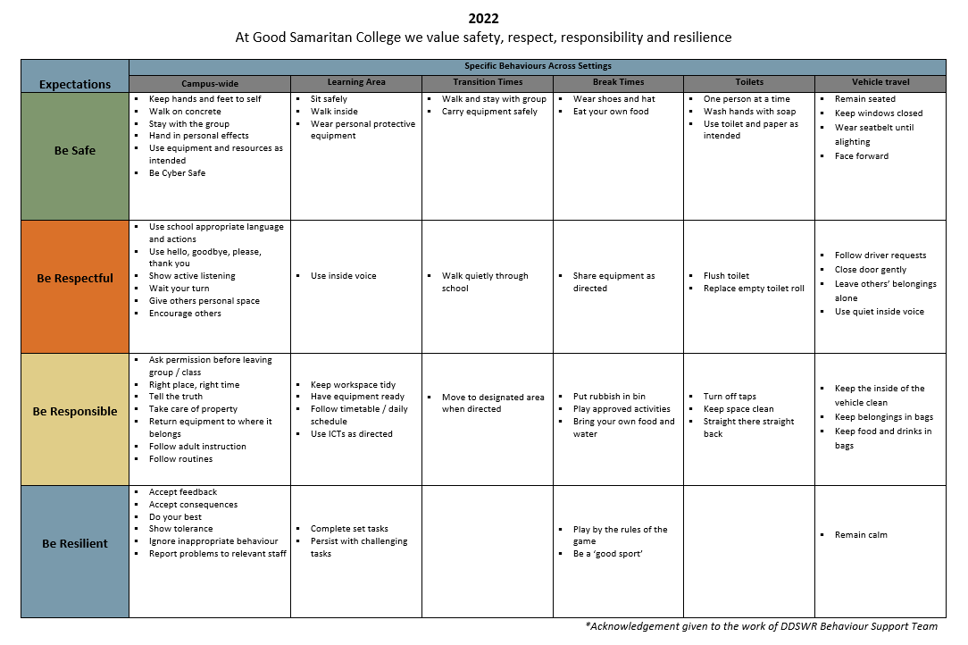
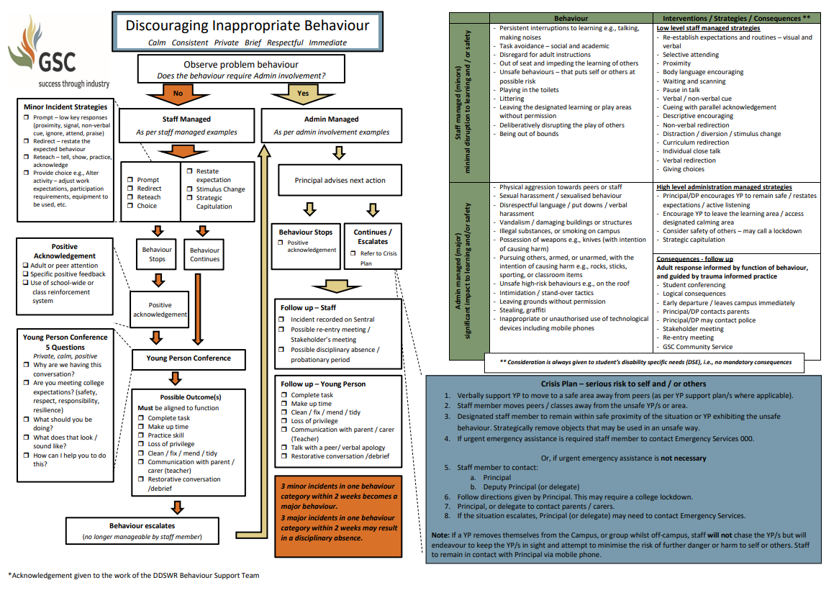
Appendix B: Discouraging Inappropriate Behaviour
Appendix C: Recognising Positive Behaviours

Level 3: Principal or Deputy Principal
Area of recognition  - academic achievement/growth  - positive behaviour demonstrated in 3 or more classes  - consistent positive behaviour in a range of school settings |  |  | Possible method of recognition  - Good Samaritan Award  - Student Council positions  - SMS of greatness
Level 2: Success Coach
Area of recognition  - positive behaviour demonstrated several times in a particular subject  - consistent positive behaviour in a subject over a school term  - positive behaviour consistently demonstrated out of class  - over 90% attendance rate |  |  | Possible method of recognition  - Merit Awards  - end of semester celebration days  - Attendance Award
Level 1: Classroom Teacher
Area of recognition
Be safe  - stay in the learning space  - keep hands, feet and objects to self  - use equipment and resources as intended  - hand in prohibited school items  - be cyber safe | Be respectful  - use school appropriate language and actions  - use hello, goodbye, please and thank you  - show active listening  - give others personal space  - encourage others | Be responsible  - ask permission before leaving the group  - right place, right time  - follow adult instructions  - take care of property, workspaces  - follow routines |  | Be resilient  - accept feedback  - accept consequences  - complete set tasks  - participate – have a go!  - ignore the inappropriate behaviour of others | Possible method of recognition  - class celebrations  - specific positive feedback  - praise  - acknowledge approximations  - inclusive end of semester celebration days  - fist pump, high five, thumbs up, clap, smile  - choice of free time activity

Appendix D: Student engagement, wellbeing and behaviour referral forms

Name of student/s involved in incident
Person completing form |  |  |  |  |  |  |  | Date
Problem behaviour (name it)
Date of incident |  |  |  | Time incident started |  |  | Time incident ended
Where was the student when the incident occurred?
Who was working with the student when the incident occurred?
Where was staff when the incident occurred?
Who was next to the student when the incident occurred?
Who else was in the immediate area when the incident occurred?
What was the general atmosphere like at the time of the incident?
What was the student doing at the time of the incident?
What occurred immediately before the incident? Describe the activity, task, event.

Describe what the student did during the incident.
Describe the level of severity of the incident eg damage, injury to self/others.
Describe who or what the incident was directed at.
What action was taken to de-escalate or re-direct the problem?
Briefly give your impression of why the student engaged in the above-described incident.

Office referral form
Name |  |  |  |  |  |  |  | Location
Date |  |  | Time |  |  |  |  | playground toilets  hallway oval   basketball court  classroom  other (please specify)
Teacher |  |  | Year level
Referring staff
Minor problem behaviour |  | Major problem behaviour |  |  |  |  | Possible motivation
- inappropriate language  - physical contact  - defiance  - disruption  - dress code  - property misuse  - other (please specify) |  | - abusive language  - fighting/physical aggression  - overt defiance  - harassment/bullying  - inappropriate display affection  - lying/cheating  - truancy  - other (please specify) |  |  |  |  | - obtain peer attention  - obtain adult attention  - obtain items/activities  - avoid Peer(s)  - avoid Adult  - avoid task or activity  - don’t know  - other (please specify)
Administrative decision
- loss of privilege  - time in office  - restorative conference with student  - parent contact |  |  |  | - individualised instruction  - in-school suspension ( ____hours/ days)  - out of school suspension ( _____ days)  - other (please specify)
Others involved in incident
none peers staff teacher relief teacher unknown other (please specify)

Other comments

Parent/carer name (please print)
Parent/carer signature
Date

Please note: All minors are to be filed with the classroom teacher. Three minors equal a major. All majors require administrator consequence, parent contact, and signature.

Office discipline referral form
Name
Date |  |  | Time
Referring staff |  |  | Year level
Others involved in incident
peers staff teacher relief teacher unknown
Issue of concern
Major problem behaviours |  | Minor problem behaviours
 abusive language   fighting/physical aggression   harassment   overt defiance   tardy   dress code   electronic violation   other (please specify) |  |  inappropriate language   disruption   property misuse   non-compliance   late to class   other (please specify)
Location |  | Possible motivation
 playground   cafeteria   hallway   bathroom   car park   classroom   restricted area   special event   common area   other (please specify) |  |  attention from peer(s)   attention from adult(s)   avoid peer(s)   avoid adult(s)   avoid work   obtain item(s)   don’t know   other (please specify)
Describe what happened
Consequences
 lose recess  lose other privilege (please specify) ___________________________
 conference  in-school suspension
 parent contact  out-of-school suspension
 clean/fix/tidy
 follow up agreement (see over page)

Follow up agreement
Name
Date |  |  |  | Year level
1. What College expectation did you not adhere to? (circle one or more than one)
Be Safe Be Respectful Be Responsible Be Resilient
2. What did you want?
 I wanted attention from others.  I wanted to be in control of the situation.
 I wanted to challenge adult(s).  I wanted to avoid doing my work.
 I wanted to be sent home.  I wanted revenge.
 I wanted to cause problems because I feel miserable inside.
 I wanted to cause others’ problems because they don’t like me.
 I wanted _________________________________________.

3. Did you get what you wanted? |  |  |  yes  no
4. What will you do differently next time?
I will be…

by…

Student’s signature
Adult’s signature

